**play an audio file from SPIFFS using PCM5102A**

the following is a guide on how to play an audio file using the PCM5102A amplifier.  
for this tutorial, we used the Arduino IDE.  
**assumptions:**

* you have downloaded the Arduino IDE.
* you have configured the IDE to work with the “DOIT ESP32 DIVKIT V1” board.
* you know how to upload a file to esp32’s SPIFFS

a guide to all the steps above can be found in the “bank of knowledge”.

**needed material:**

* ESP32 microcontroller
* PCM5102A amplifier
* breadboard
* WiFi connection
* 7 wires
* earphones with an aux jack

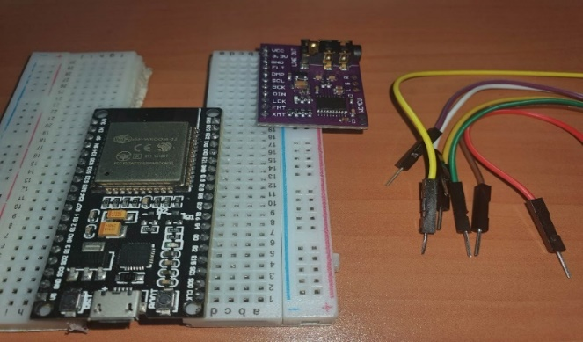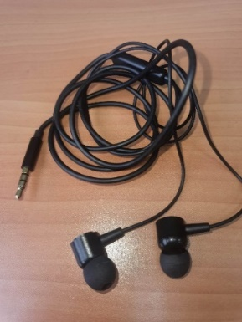

**step 1:** download the following Github repository as a zip file to your computer:  
<https://github.com/schreibfaul1/ESP32-audioI2S>  
  
**step 2:** go to the Arduino IDE -> Sketch -> include library -> add .ZIP library -> choose the file you’ve downloaded in step 1.

**step 3:** setup the wiring as shown in the “audio input and output for microcontrollers” presentation, or as follows:

|  |  |
| --- | --- |
| **PCM5102/A** | **ESP32** |
| Vcc | Vcc (5V) |
| GND | GND |
| BCK or BCLK | Pin 27 (G27) |
| DIN | Pin 25 (G25) |
| LCK | Pin 26 (G26) |
| FMT | GND |
| XMT | Vcc (5v\3.3v) preferably 3.3V |

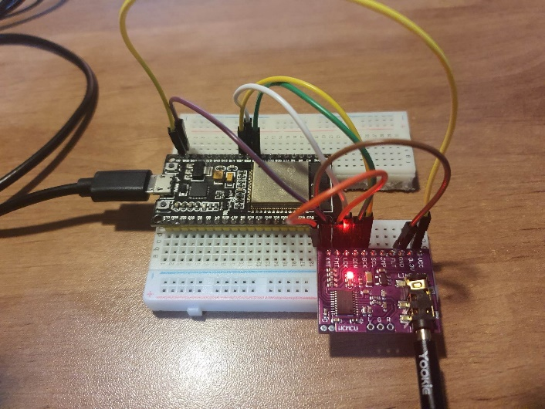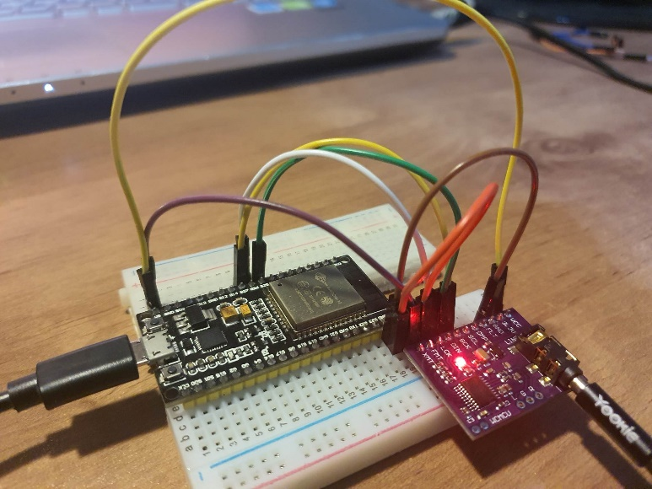

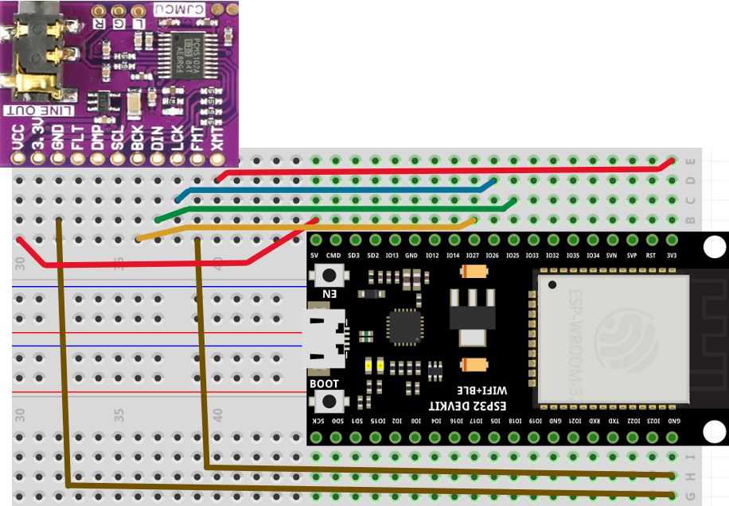

**step 4:** copy and paste the following code:

//#include "Arduino.h" //required for PlatformIO  
#include "Audio.h"  
#include "FS.h"  
  
// Digital I/O used for I2S DAC amplifier  
#define I2S_DOUT 25  
#define I2S_BCLK 27  
#define I2S_LRC 26  
  
Audio audio;  
  
void setup() {  
  
 Serial.begin(115200);  
  
 if (!SPIFFS.begin(true)) {  
 Serial.println("An Error has occurred while mounting SPIFFS");  
 return;  
 }  
  
 audio.setPinout(I2S_BCLK, I2S_LRC, I2S_DOUT);  
 audio.setVolume(20); // range 0...21 - This is not amplifier gain, but controlling the level of output amplitude.   
  
 audio.connecttoFS(SPIFFS, "123_u8.wav"); // a file with the proper name must be placed in /data folder and uploaded using "ESP32 sketch upload" plugin  
  
 audio.setFileLoop(true); //this causes the file to play in an endless loop  
}  
  
void loop()  
{  
 audio.loop();  
 if (Serial.available()) { // put streamURL in serial monitor  
 audio.stopSong();  
 Serial.println("audio stopped");  
 log_i("free heap=%i", ESP.getFreeHeap());  
  
 }  
}

**NOTE:** make sure that the defined Pins match the wiring, and that the file name matches the one you uploaded to SPIFFS.

**step 5:** connect the ESP32 to your computer, compile and run the code, and then connect your earphones to the aux jack on your PCM5102. you might need to press on the “reset” button on your ESP32.  
**NOTE:**

* it doesn’t matter if the earphones were already connected or not when the code was being uploaded to the esp32.
* the earphones connection is a bit sensitive. if you don’t hear a sound, try moving the headphone jack a little bit.
* the following code plays the file in a loop. sometimes the audio plays for 1\2 times only for some unknown reason. changing the port which the esp32 is connected to seems to help!

**step 6:** enjoy 😊